ECE 579 Intelligent Systems, Fall 2023

Final Project Report

**Project Title:** Vehicle Battery SOC Estimation Utilizing Machine Learning

**Student names**: Onkar Gunjkar, Axel Aguilar, Harshit Barde

**Department name(s)** : Onkar Gunjkar(Electrical Engineering), Axel Aguilar(Artificial Intelligence), Harshit Barde( Data Science)

**Responsibilities of each student:** Onkar Gunjkar (Data Cleaning, Processing, Exploratory Data Analysis, and Integration), Axel Aguilar (Simulation and Experimentation), and Harshit Barde (Machine Learning and Algorithm).

1. **Introduction:**

The purpose of this project will be to estimate and optimize the %SOC value for a Vehicle Battery which will help us to provide a more accurate autonomy value for a given vehicle.

The number indicating the total available usable energy in a High voltage Battery is defined as the state of charge given in a percentage value, knowing the state of charge value is critical for EVs or HEVs to calculate what is the range value in km or miles.

In this report, we will illustrate the different Machine learning approaches to estimate the %SOC of Vehicle Batteries from input parameters like Battery Voltage, Battery Current, and Battery Temperature. Also, we will be developing and simulating this process in real-time by utilizing MATLAB and Simulink. We will compare the different approaches through experimentation.

1. **Description of technologies related to your project:**

Python and MATLAB will be used for Data processing and visual representation. Additionally, we will be using Google Collab to work together on a project and go through training processes and data acquisition utilizing Neural Network generation libraries from packages of TensorFlow and Keras.

Different Neural Network techniques can be used either using MATLAB or Python, moving forward, here is a breakdown description of different algorithm techniques we could use for our development:

**Layered Representation**:

A network which has an organized input layer, multiple hidden layers and output layer is called a deep neural network. Each layer contains interconnected artificial neurons or units. These layers are like a hierarchy of processing stages.

**Forward Propagation**:

Information flows through the network in a forward direction. At the input layer, the network receives data, such as numbers representing features. Each neuron in a layer receives input from the previous layer, then it tries to update weights and do the sum of inputs by taking these weights into account, later bias is added and then activation function receives the input and forms the result.

**Training and Backpropagation**:

The process of teaching deep neural networks by using data is called training. During training, the network is shown examples of input data with known correct answers. It compares its predictions to the correct answers and adjusts the weights and biases of the neurons to reduce the difference (or error). This process is called backpropagation, and it calculates how much each weight and bias contributed to the error, allowing the network to update its parameters and improve its predictions.

**Non-Linear Feature Learning**:

Deep neural networks are mighty because they can capture intricate and non-linear relationships in the data. Each layer, with its activation functions, allows the network to discover and represent complex patterns and features in the data.

**Feed Forward Neural Network:**

Neural networks which do not have feedback nodes are called Feed Forward Neural Network. Data flow involves the receipt of data at input nodes, transmission across covert layers, and output at nodes. There are no linkages in the network that could be manipulated to convey data back from the output node.

1. **Methods used in the project:**

We started merging all of the trip data's data files. We preprocessed the data in the following stage so that it was prepared for additional processing and analysis. Plots for data visualization are then created to extract insights from the data. To achieve the best results in the upcoming phase of the project, we are developing various machine-learning models. The models we are utilizing are as follows:

**Linear Regression:** It is the method to establish the relationship between one dependent variable and one or more independent variables. It assumes that there is a linear relationship between the variables, which states that variations in the independent variables are always accompanied by variations in the dependent variable. A linear equation representing the model's dependent variable (yy), independent variable (xx), slope (mm), and y-intercept (bb) is commonly written as y=mx+by=mx+b.

**Neural Networks**: A class of machine learning models called neural networks is modeled after the composition and operations of the human brain. Neural networks are hierarchically structured collections of interconnected nodes, or artificial neurons, arranged into layers to process information. Data is first received by the input layer and then spreads through hidden layers, each of which has weighted connections that alter the input. The output, or prediction, is generated by the last layer.

We tried to predict the %SOC by training these 3 models on our training data, finding out the loss metric given by each algorithm, and then selecting the algorithm that gave us the least loss.

The linear regression algorithm gave us a loss of 6.83 percent, the Feed Forward algorithm gave us the least loss of around 0.9 percent on test data after training for 100 epochs.

So, we selected the neural network model to do further experiments on our simulation circuit in MATLAB Simulink.

1. **Experiments:**

**Data description:** We are utilizing experimental data from vehicle batteries.

In the given dataset, numerous driving cycles are provided. For our interest, the following input features are the ones we used: Voltage, Current, and Temperature. Also referred to as predictor values. The target value is intended for the State of Charge.

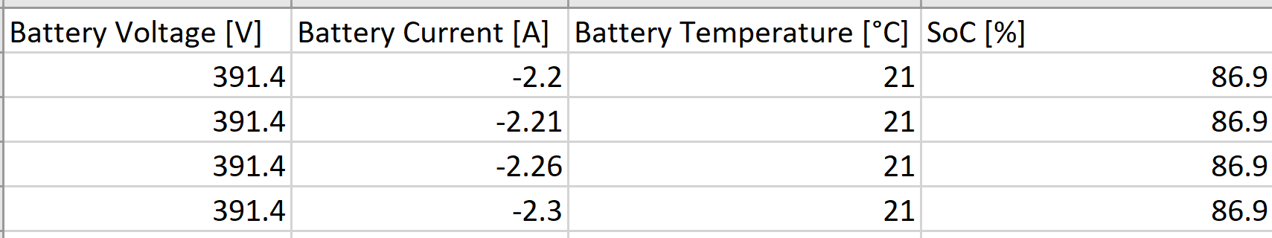

*Figure 1 High Voltage Battery Dataset snippet*

**Linear Regression Feed Forward Neural Network**

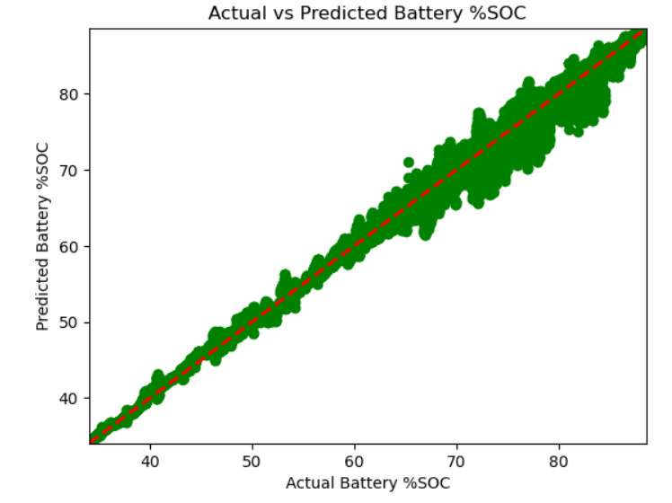

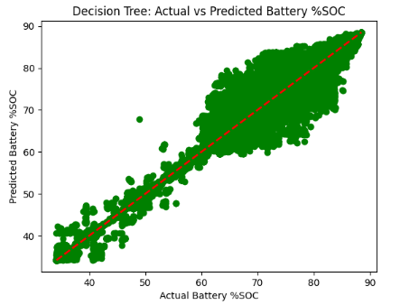



We built a simulated circuit that provides all the physics from the real battery in real time provided us with a framework in which we can utilize our models and see how they do in predicting the State of charge.



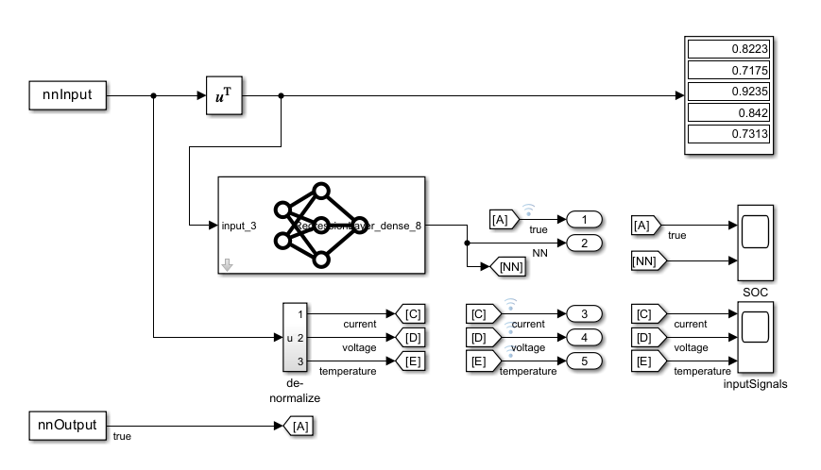

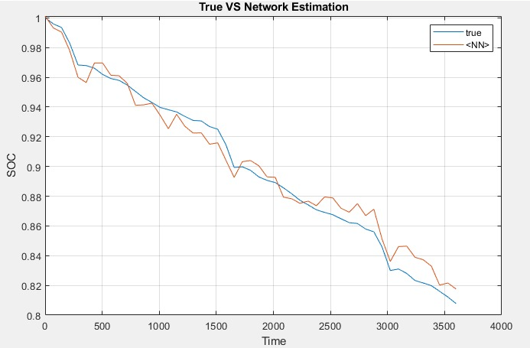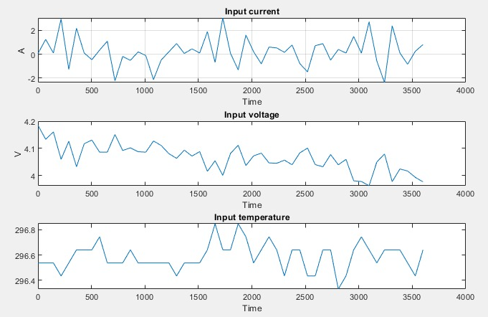



 

As a result, we’ve successfully Imported our FNN trained model from Tensor Flow into Simulink and predicted SoC%.

1. **Conclusion**

**Objective Achieved:**

Successfully calculated vehicle battery State of Charge (% SOC) using MATLAB/Simulink real-time simulation and machine learning. Inputs included Temperature, Current, and Battery Voltage.

**Model Assessment:**

Tested Decision Trees, Feed Forward Neural Networks, and Linear Regression. The Feed Forward Neural Network exhibited the best performance with a 3.16% loss, selected for further real-time testing.

**Integration and Experimentation:**

Applied models to estimate %SOC using experimental vehicle battery data (Trip_A and Trip_B).

Integrated models into a simulated circuit for real-time %SOC prediction, showcasing the Feed Forward Neural Network's accuracy.

1. **References.**

[1] Suwarna Shete; Pranjal Jog; R. K. Kumawat; D.K. Palwalia “Battery Management System for SOC Estimation of Lithium-Ion Battery in Electric Vehicle: A Review”.2021 6th IEEE International Conference on Recent Advances and Innovations in Engineering (ICRAIE):01-03 December 2021

[2] Javier Sedano, Miguel Portal, Alejandro Hernández-Arauzo, José R. Villar, Jorge Puente, Ramiro Varela“INTELLIGENT SYSTEM FOR ELECTRIC VEHICLE CHARGING:DESIGN AND OPERATION”

[3]Mahmoud Ismail; Rioch Dlyma; Ahmed Elrakaybi; Ryan Ahmed; Saeid Habibi. “Battery state of charge estimation using an Artificial Neural Network”. 2017 IEEE Transportation Electrification Conference and Expo (ITEC), 22-24 June 2017.

[4] S. Qingsheng, Z. Chenghui, C. Naxin, and Z. Xiaoping, "Battery state-of-charge estimation in the electric vehicle using Elman neural network method", Control Conference (CCC) 2010 29th Chinese*,* pp. 5999-6003, 2010.

[5] Z. Chen, S. Qiu, M. A. Masrur and Y. L. Murphey, "Battery state of charge estimation based on a combined model of extended Kalman filter and neural networks", Neural Networks (IJCNN) The 2011 International Joint Conference,pp. 2156-2163, 2011.

[6] Vidal, C., Kollmeyer, P., Naguib, M., Malysz, P., et al., "Robust xEV Battery State-of-Charge Estimator Design Using a Feedforward Deep Neural Network," *SAE Int. J. Adv. & Curr. Prac. in Mobility* 2(5):2872-2880, 2020, <https://doi.org/10.4271/2020-01-1181>.